Supplementary Materials
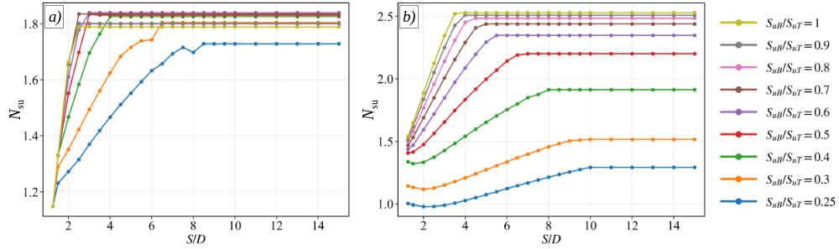
Figure S.1. Effect of tunnel spacing and clay strength ratio on N_{su} for shallow cover conditions at Z/D = 1.5: a) C/D = 1.5; b) C/D = 2.0.
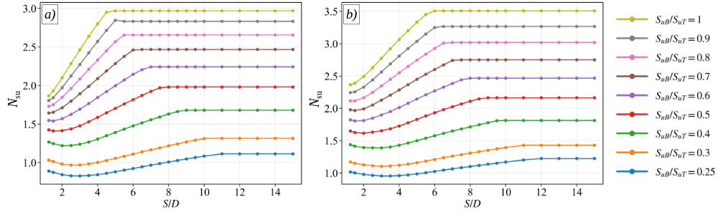
Figure S.2. Effect of tunnel spacing and clay strength ratio on N_{su} for shallow cover conditions at Z/D = 1.5: a) C/D = 2.5; b) C/D = 3.0.
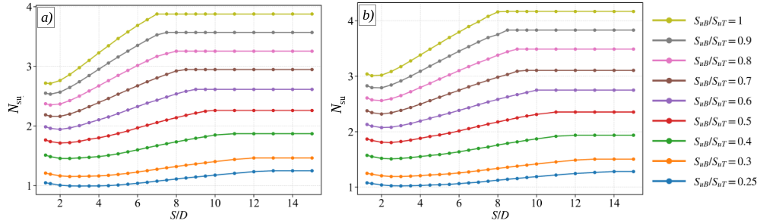
Figure S.3. Effect of tunnel spacing and clay strength ratio on N_{su} for shallow cover conditions at Z/D = 1.5: a) C/D = 3.5; b) C/D = 4.0.
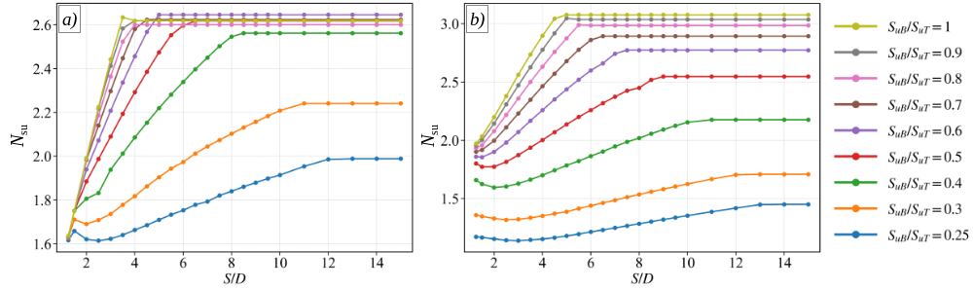
Figure S.4. Effect of tunnel spacing and clay strength ratio on N_{su} for shallow cover conditions at Z/D = 2.0: a) C/D = 1.5; b) C/D = 2.0.
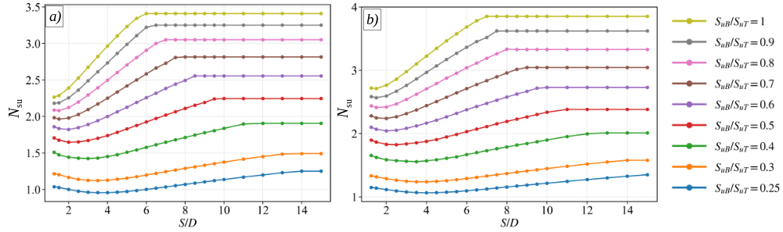
Figure S.5. Effect of tunnel spacing and clay strength ratio on N_{su} for shallow cover conditions at Z/D = 2.0: a) C/D = 2.5; b) C/D = 3.0.
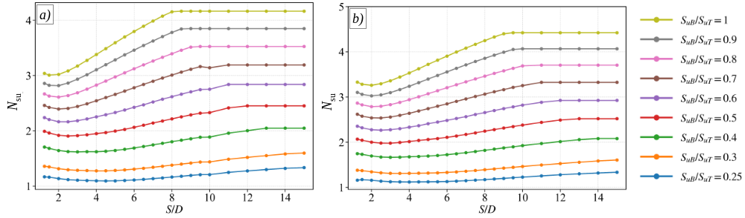
Figure S.6. Effect of tunnel spacing and clay strength ratio on N_{su} for shallow cover conditions at Z/D = 2.0: a) C/D = 3.5; b) C/D = 4.0.
Figure S.7. Effect of tunnel spacing and clay strength ratio on N_{su} for shallow cover conditions at Z/D = 3.0: a) C/D = 1.5; b) C/D = 2.0.
Figure S.8. Effect of tunnel spacing and clay strength ratio on N_{su} for shallow cover conditions at Z/D = 3.0: a) C/D = 2.5; b) C/D = 3.0.
Figure S.9. Effect of tunnel spacing and clay strength ratio on N_{su} for shallow cover conditions at Z/D = 3.0: a) C/D = 3.5; b) C/D = 4.0.

